## Begin

I’m thinkey, can u tell me about your backgroud and how it led you to apply for this role?

brief introduce for you and the project you have responsible for?

Let's begin with some Java basics questions.

## Java basics

**Explain about Arraylist, hashmap , hashtable ,and concurrenthashmap internal working**

ArrayList ：dynamic array 、randAccess默认0第一次10 1.5倍expance capacity 【kəˈpasɪti 】

Hashmap is implemented by arrays, linked lists, and red-black trees

concurrenthashmap：syn + cas + node + 红黑树

reentrantlock + segment + hashentry

Hashtable：一把锁，同时阻塞read write，效率低

### ArrayList LinkedList

<https://www.cnblogs.com/lingshang/p/10897912.html>

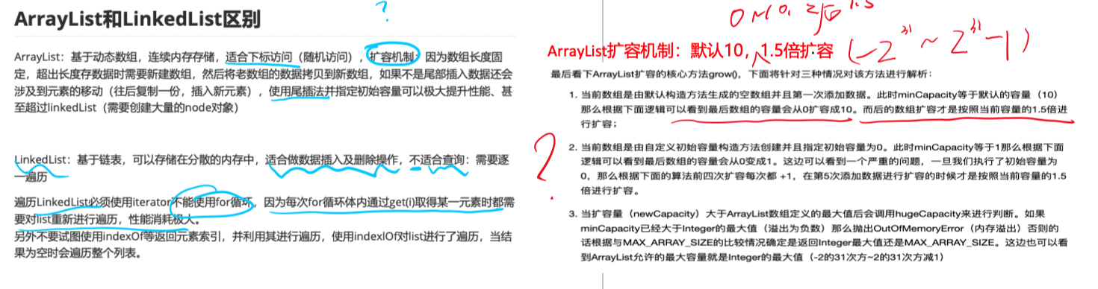

### String / StringBuffer / StringBuilder

* Why is String immutable?
* 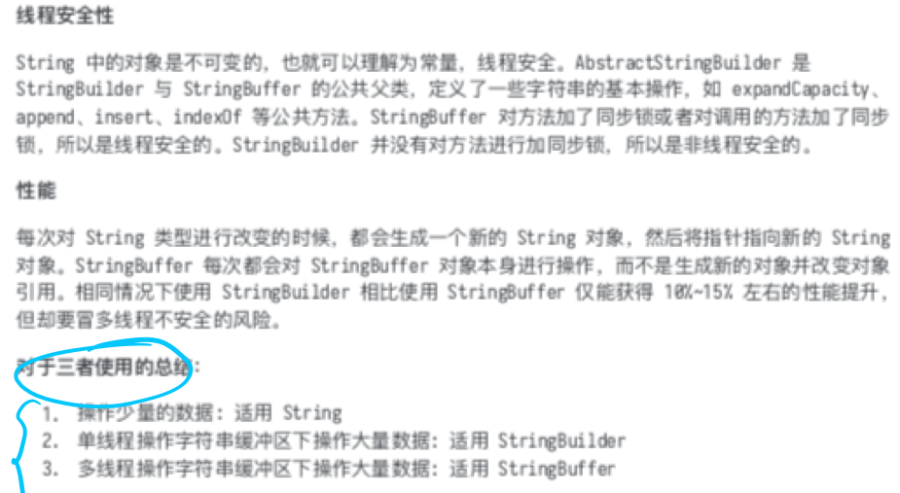

### hashmap和hashtable的区别

### HashMap

* data structure
* What's the difference between before and after jdk8?
* How to resolve hash conflicts？
* Is it thread-safe? If I want a thread-safe collection like Hashmap. What can I choose

### ConcurrentHashMap

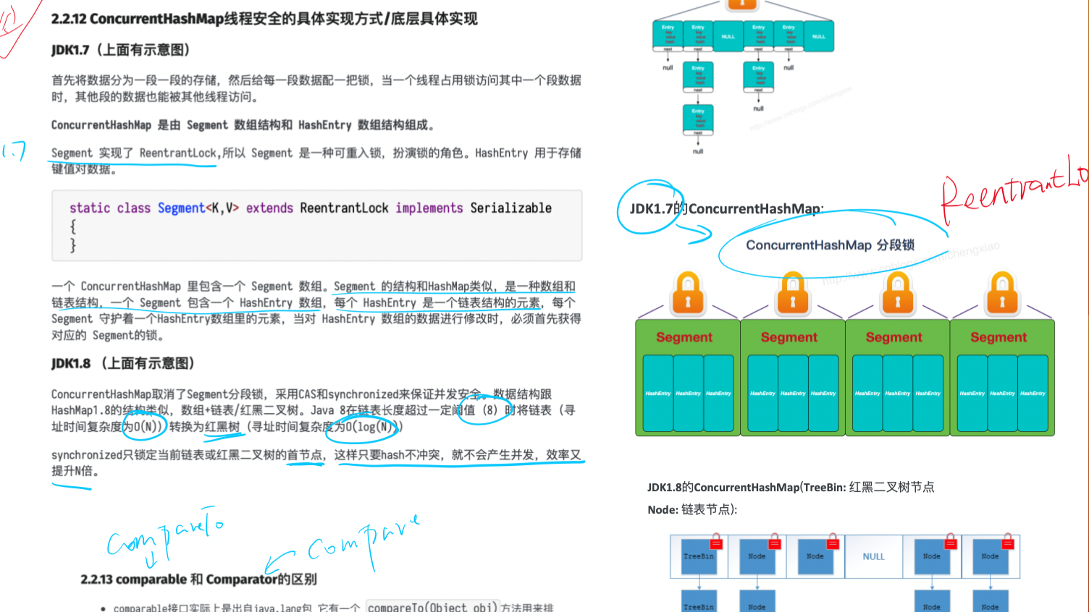

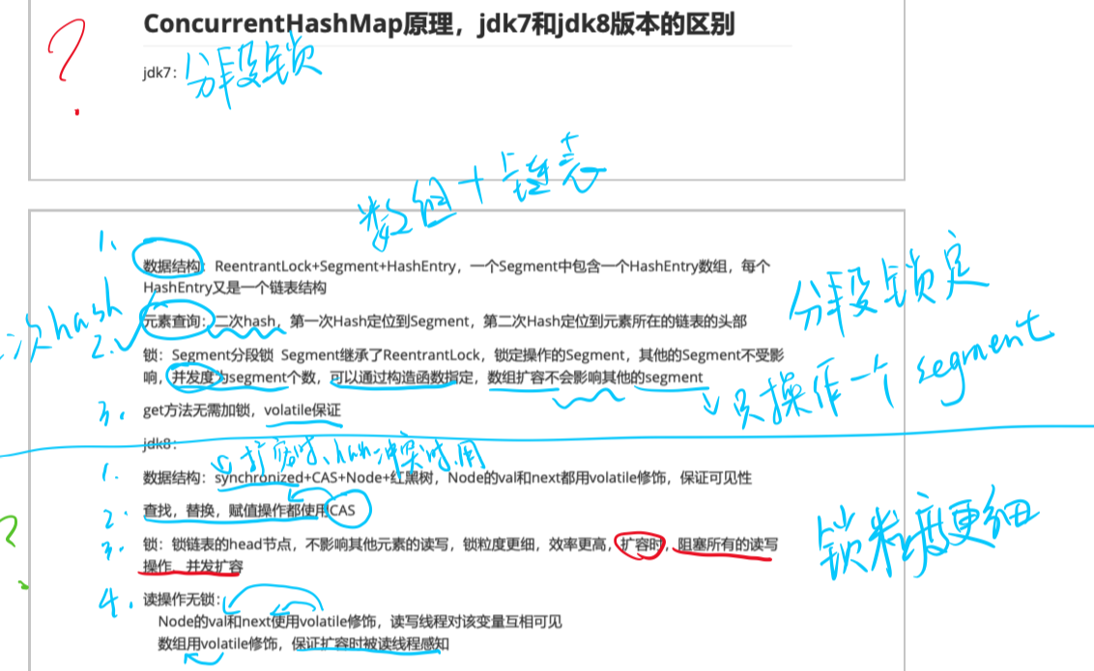

### Abstract class and Interface

* Pls explain the difference Between Abstract class and Interface

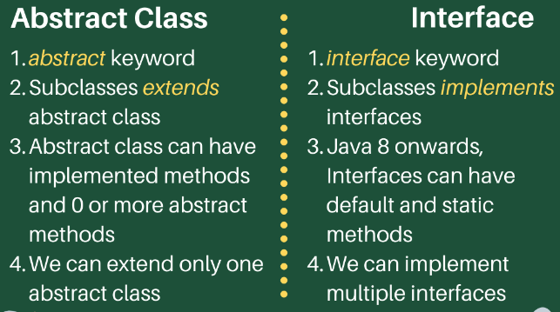

### garbage collection

* Can you explain how garbage collection works in Java and what are some best practices for optimizing memory usage?

## Java Lock

### Synchronize volatile

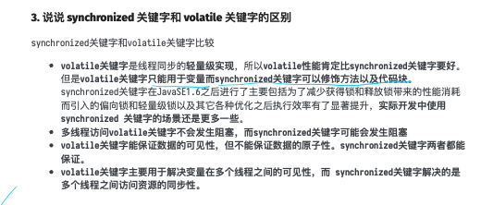

### Synchronize ReentrantLock

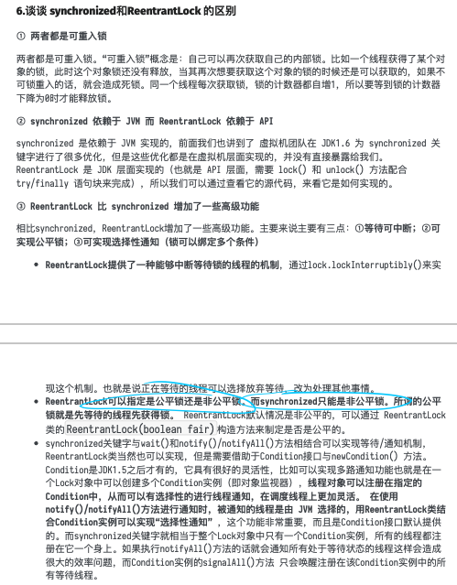

* Synchronize - The lock upgrade process

## Java MultiThread

* Can you describe your experience with multithreading in Java and how you handle concurrency issues?
* Briefly describe the processing flow of java thread pools？
* 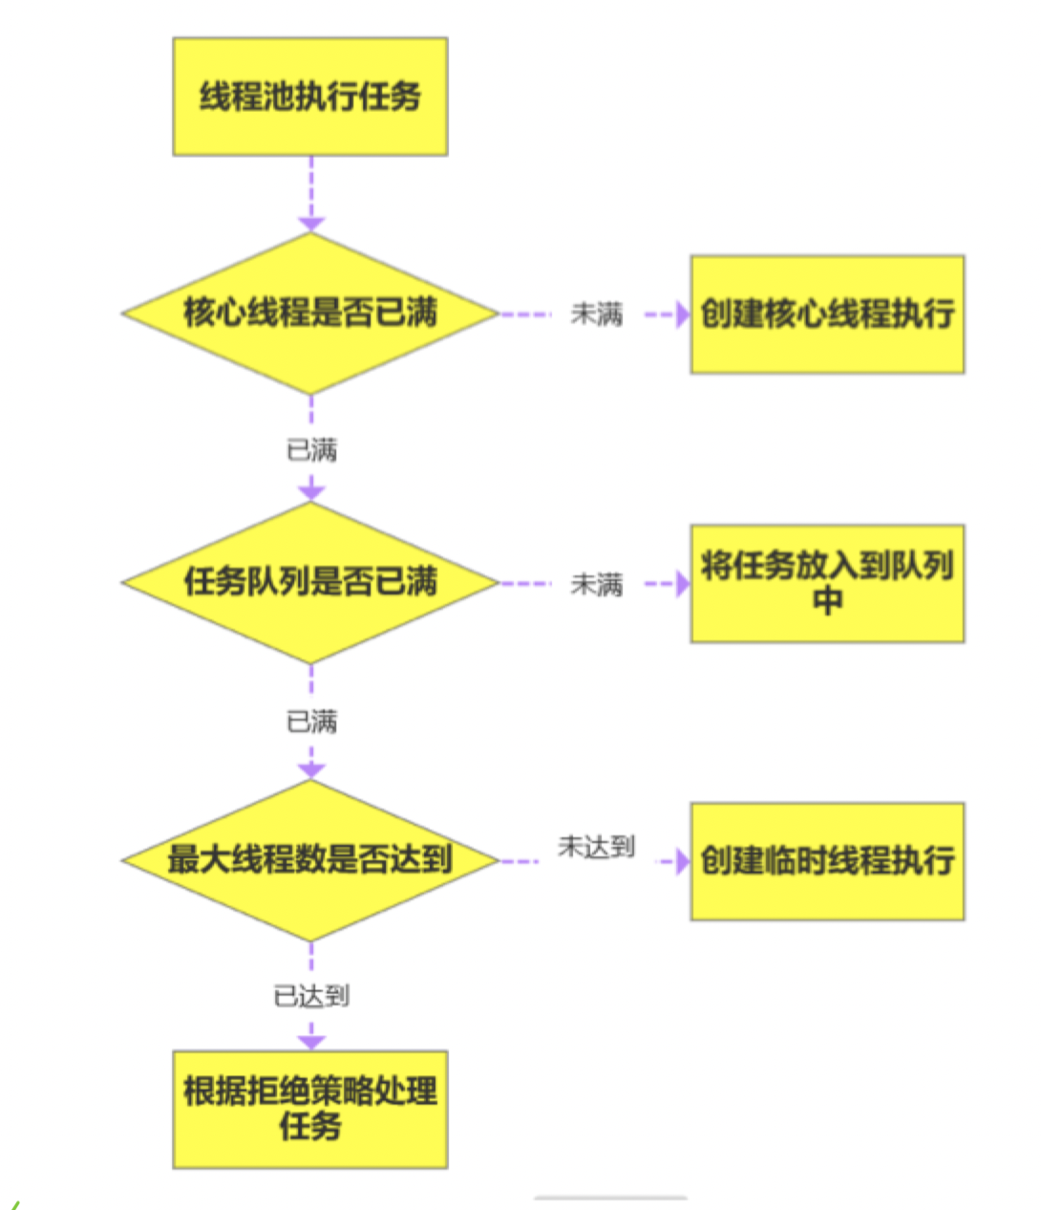
* Can you share something A related? Whatever you want.
* thread pool parameter：CorePoolSize MaxinumPoolSize KeepAlive
* ‌How many denial strategies are there for thread pools? What are each of them？
* **线程池的拒绝策略主要有四种：‌[AbortPolicy](https://www.baidu.com/s?wd=AbortPolicy&usm=1&ie=utf-8&rsv_pq=e5d5dbf800b9f611&oq=%E7%BA%BF%E7%A8%8B%E6%B1%A0%E6%8B%92%E7%BB%9D%E7%AD%96%E7%95%A5&rsv_t=2db3XzL7wJd9OI3ZGlqD5vjSbmCh6Q7A%2FU539n8XCXdCudyhsU4JT6CtgXM&sa=re_dqa_generate" \t "_self)、‌[CallerRunsPolicy](https://www.baidu.com/s?wd=CallerRunsPolicy&usm=1&ie=utf-8&rsv_pq=e5d5dbf800b9f611&oq=%E7%BA%BF%E7%A8%8B%E6%B1%A0%E6%8B%92%E7%BB%9D%E7%AD%96%E7%95%A5&rsv_t=a696ythlvG8WlVOfbh7hKhMYqK4W0KzcBnGeJhuXbvur9AC3MEi7CUYMNZQ&sa=re_dqa_generate" \t "_self)、‌[DiscardOldestPolicy](https://www.baidu.com/s?wd=DiscardOldestPolicy&usm=1&ie=utf-8&rsv_pq=e5d5dbf800b9f611&oq=%E7%BA%BF%E7%A8%8B%E6%B1%A0%E6%8B%92%E7%BB%9D%E7%AD%96%E7%95%A5&rsv_t=a696ythlvG8WlVOfbh7hKhMYqK4W0KzcBnGeJhuXbvur9AC3MEi7CUYMNZQ&sa=re_dqa_generate" \t "_self)和‌[DiscardPolicy](https://www.baidu.com/s?wd=DiscardPolicy&usm=1&ie=utf-8&rsv_pq=e5d5dbf800b9f611&oq=%E7%BA%BF%E7%A8%8B%E6%B1%A0%E6%8B%92%E7%BB%9D%E7%AD%96%E7%95%A5&rsv_t=a056KjtOwjKE0JHuDnp92E7nMgtdrUAPJcN9K%2FSvJtmXuxJ8PkvLY9R1gig&sa=re_dqa_generate" \t "_self)。**‌‌12

### ThreadLocal

<https://blog.csdn.net/u010445301/article/details/111322569>

* It may lead to memory leaks, how to avoid

## Kafka

<https://1drv.ms/o/c/204f33561bc7cd38/EjjNxxtWM08ggCAXBQAAAAABaJfo-lDMABeT0j2f6O_FMw>

### Kafka structure

* can you briefly decribe for Kafka Architecture?
* Can you give a brief overview of the Kafka structure?
* 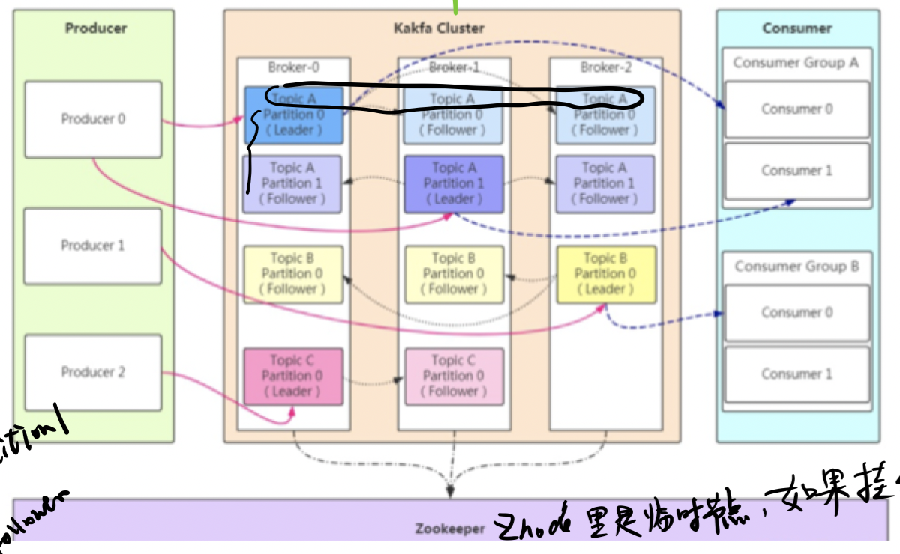

### Kafka rebalance

* Do you know kafka rebalance? Can you briefly describe the kafka relalance process?
* When does it happen？
* How to deal with this issues

<https://www.cnblogs.com/chanshuyi/p/kafka_rebalance_quick_guide.html>

### Kafka lose message

* In-Sync Replicas (ISR)
* When is Kafka likely to lose messages?

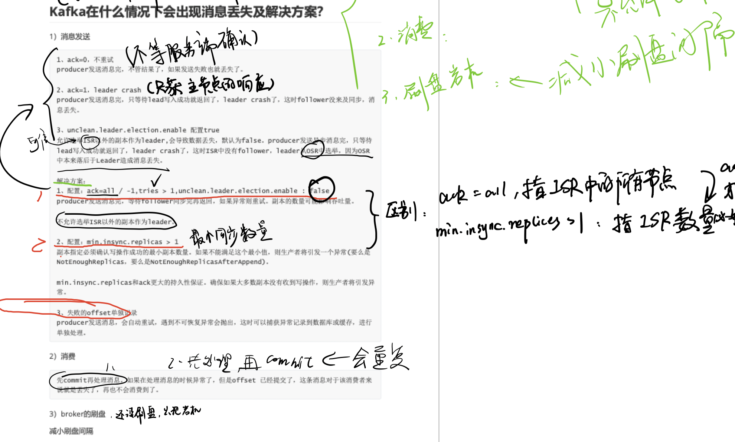

## Spring Springboot

### What is the Difference @Component & @Service

* Have you ever used custom annotations?
* Explain Transation Management 【When does it not work?】

How did you implement in your application.

【getTransaction、commit、rollback】

* Explain Spring bean Life Cycle

## SpringSecurity

* What is JWT Token？header payload、signature

### Explain about Spring security

Explain how did you validate a user in your application

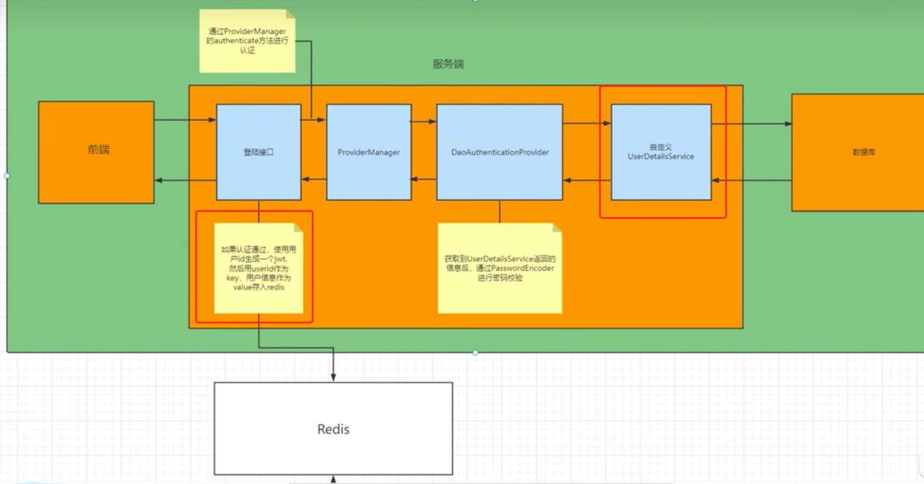

## Mysql

* What is the difference between PRIMARY KEY and combined key in Mysql
* If a particular query SQL is running slowly, what should I do when checking for improvements?

## Junit

**Do you write Junites?**

Mockito ,coverage

What framework you use?

What keywork will use if you want to mock an exception?

## Open-ended question

Can you tell me about a challenging project you worked on in Java and how you overcame any obstacles?

## Test

Finally, let's do a code test

Can you share your screen?

### Test1

How to find duplicate elements in a given integers list in java using Stream functions?

//1,1,1,2,2,3,4,5,6,7 ===》 1,2,3,4,5,6,7

List<Integer> l = Arrays.*asList*(1,1,1,2,2,3,4,5,6,7);

### Test2

Filtering Repeated Words

//Hi Lili Lili, Good Good Luck!

//=>>>

//Hi Lili, Good Luck!